- Copyright for test papers and marking guides remains with West Australian Test Papers.
- The papers may only be reproduced within the purchasing school according to the advertised conditions of sale.
- Test papers must be withdrawn after use and stored securely in the school until Wednesday 1st July 2015.

CHEMISTRY
UNIT 1
2015


Name: _________________________________________________________________________________________

Teacher: ________________________________________________________________________________________

TIME ALLOWED FOR THIS PAPER

Reading time before commencing work: Ten minutes
Working time for the paper: Three hours

MATERIALS REQUIRED/RECOMMENDED FOR THIS PAPER

To be provided by the supervisor:
- This Question/Answer Booklet
- Multiple-choice Answer Sheet
- Chemistry Data Sheet

To be provided by the candidate:
Standard items: pens (blue/black preferred), pencils (including coloured), sharpener,
eraser, correction tape/fluid, ruler, highlighters

Special items: non-programmable calculators approved for use in the WACE
examinations

IMPORTANT NOTE TO CANDIDATES

No other items may be taken into the examination room. It is your responsibility to ensure that you do not have any unauthorised notes or other items of a non-personal nature in the examination room. If you have any unauthorised material with you, hand it to the supervisor before reading any further.
Structure of this paper

Section | Number of questions available | Number of questions to be answered | Suggested working time  (minutes) | Marks available | Percentage of exam
Section One:  Multiple-choice | 25 | 25 | 50 | /50 | /25
Section Two:  Short answer | 14 | 14 | 60 | /70 | /35
Section Three:  Extended answer | 5 | 5 | 70 | /80 | /40
 |  |  |  |  | /100

Instructions to candidates

1. Answer the questions according to the following instructions.

Section One: Answer all questions on the separate Multiple-choice Answer Sheet provided. For each questions shade the box to indicate your answer. Use only a blue or black pen to shade the boxes. If you make a mistake, place a cross through that square then shade your new answer. Do not erase or use correction fluid/tape. Marks will not be deducted for incorrect answers. No marks will be given if more than one answer is completed for any question.

Sections Two and Three: Write your answers in this Question/Answer Booklet.

2. When calculating numerical answers, show your working or reasoning clearly. Express numerical answers to three significant figures and include appropriate units where applicable.

3. You must be careful to confine your responses to the specific questions asked and to follow any instructions that are specific to a particular question.

4. Spare pages are included at the end of this booklet. They can be used for planning your responses and/or as additional space if required to continue an answer.
  - Planning: If you use the spare pages for planning, indicate this clearly at the top of the page.
  - Continuing an answer: If you need to use the space to continue an answer, indicate in the original answer space where the answer is continued, i.e. give the page number. Fill in the number of the question(s) that you are continuing to answer at the top of the page.
PART 1 - MULTIPLE CHOICE [50 MARKS – 25%]

Section One: Multiple-choice 25% (50 marks)

This section has 25 questions. Answer all questions on the separate Multiple-choice Answer Sheet provided. For each question, shade the box to indicate your answer. Use only a blue or black pen to shade the boxes. If you make a mistake, place a cross through that square then shade your new answer. Do not erase or use correction fluid/tape. Marks will not be deducted for incorrect answers. No marks will be given if more than one answer is completed for any question.

Suggested working time: 50 minutes.

- Which element does NOT form ions with the same electron configuration as argon?

  - S
  - Ca
  - Aℓ
  - Cℓ

- Using the given coefficients, balance the unbalanced equation below:

… Na₃PO₄(aq) + … CaCℓ₂(aq) … NaCℓ(aq) + … Ca₃(PO₄)₂(s)

  - 1, 3, 3, 1
  - 2, 3, 3, 2
  - 2, 3, 6, 1
  - 2, 3, 3, 1

- A metal (X) ion combines with the oxide ion to form an ionic compound with the formula X₂O₃. Which of the following is the most likely formula when X combines with the nitride ion?

  - X₂N₃
  - XN
  - X₃N₂
  - XN₃

- Which of the following compounds has a bonding structure which differs from the other three?

  - Na₂SO₄
  - RbOH
  - NH₄Cℓ
  - SiO₂
- In which of the following molecules would you find six electrons shared between two bonding atoms?

  - Oxygen gas
  - Ethane gas
  - Ammonia gas
  - Nitrogen gas

- Electronegativity tends to increase as:

  - You go down a group of the periodic table
  - You go from left to right across a period of the periodic table
  - The atomic number increases
  - The valency of the common ion increases

- Which of the following statements is the best definition of ionisation energy?

  - It is the energy needed to change a mole of a substance from a liquid to a gas
  - It is the energy required to dissociate one mole of ions in the solid phase
  - It is the energy required to remove a mole of electrons from a mole of atoms or ions of an element in the gas phase
  - It is the energy required to form one mole of an ionic substance from its constituent atoms

- The gold foil experiment was conducted by Ernest Rutherford. What information did this experiment provide Rutherford about the internal structure of atoms?

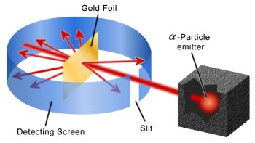
  - Atoms contain small positively charged particles
  - Atoms contain small negatively charged particles
  - Electrons exist in discrete energy levels
  - The positive charge of an atom is concentrated in the nucleus

- The periodic table arranges elements into periods and groups. What is the main criteria used to order elements within a period?

  - Increasing atomic number
  - Number of valence electrons
  - Number of electron shells filled
  - Increasing mass number

- The emission spectra produced by four different elements are shown below.
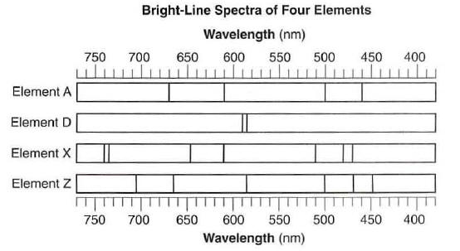

The following spectrum is produced from a mixture containing two of the above elements.

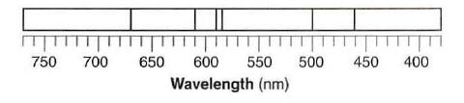

Which elements are present in the mixture?

  - Elements A and D
  - Elements A and X
  - Elements Z and D
  - Elements Z and X

- Why does each element emit multiple wavelengths of light?

  - There are many ground states in an atom
  - Atoms can release multiple photons at once
  - There are different isotopes of each element
  - There are many excited states in an atom

- Mass spectrometers separate isotopes of different elements based on their:

  - Mass only
  - Electric charge only
  - Mass and electric charge
  - Wavelength of photons

- Which of the following substances has a combination of covalent and ionic bonding?

  - CsF(s)
  - Ca₃(PO₄)₂(s)
  - HF(g)
  - C(s) (graphite)

- Which of the following calculations correctly shows the percentage of carbon in one molecule of ethane?

(a) | $$\%C= \frac{12.01}{12.01×2+1.008×4}=42.8\%$$
(b) | $$\%C= \frac{12.01×2}{12.01×2+1.008×4}=85.6\%$$
(c) | $$\%C= \frac{12.01}{12.01×2+1.008×6}=39.9\%$$
(d) | $$\%C= \frac{12.01×2}{12.01×2+1.008×6}=79.9\%$$

- Which of the following is always produced during combustion of fossil fuels?

  - Water
  - Carbon (soot)
  - Sulfur dioxide
  - Carbon monoxide

- Iodine readily sublimes from solid to gas when moderately heated. Which of the following options correctly describes the nature of iodine particles in the solid and gaseous phases?

 | Structure of solid iodine | Structure of gaseous iodine
(a) | Ionic network | Individual atoms
(b) | Ionic network | Discrete molecules
(c) | Discrete molecules | Individual atoms
(d) | Discrete molecules | Discrete molecules

- What distinguishes pure substances from mixtures?

  - Pure substances have more than one type of atom in a fixed ratio
  - Pure substances are homogeneous in nature
  - Pure substances are made of one type of atom only
  - Pure substances have fixed chemical and physical properties

- What is the correct IUPAC name for the following compound?

CH₃–CH₂–CH₂–CH–CH₂–Cℓ
|
CH₃

  - 5-chloro-4-methylpentane
  - 4-methyl-5-chloropentane
  - 1-chloro-2-methylpentane
  - 2-methyl-1-chloropentane

- Which of the following compounds readily undergoes addition reactions?

  - Ethane
  - Benzene
  - Propene
  - Tetrachloromethane

- When ethene gas is reacted with bromine water, which of the following gives the correct product or products?

  - bromoethane and hydrogen bromide
  - 1,1-dibromoethane
  - 1,2-dibromoethane
  - hexabromoethene

- The enthalpy of combustion of methane (CH₄) is -882 kJ mol⁻¹. What mass of methane would be needed to be burned to produce 88.2 kJ of energy?

  - 1.6 g
  - 16 g
  - 88.2 g
  - 882 g

- Which one of the following substances conducts electricity due to the movement of oppositely charged ions?

  - Aluminium metal
  - Graphite
  - Solid zinc chloride
  - Molten sodium chloride

- Propane is commonly used as a fuel for portable stoves. It combusts with oxygen to produce carbon dioxide and water. The reaction is commonly represented as:

C₃H₈(g) + 5O₂(g) 3CO₂(g) + 4H₂O(g)

Which of the following alternatives accurately represents a correct mole relationship for the above reaction?

(a) | $$n\left({CO}_{2}\right)=\frac{5}{3} × n\left(O_{2}\right)$$
(b) | $$n\left(H_{2}O\right)=\frac{5}{4} × n\left(O_{2}\right)$$
(c) | $$n\left({CO}_{2}\right)=\frac{3}{5} × n\left(O_{2}\right)$$
(d) | $$n\left(H_{2}O\right)=\frac{3}{4} × n\left({CO}_{2}\right)$$

- When magnesium is heated in the presence of oxygen it emits a bright light. What term can be used to describe this reaction?

  - Exothermic
  - Endothermic
  - Empirical
  - Spontaneous

- Which of the following hydrocarbons has NOT been named correctly?

  - ethylpentane
  - 2-ethylbutane
  - 2,2-dimethylbutane
  - 2,3-dimethylbutane

PART 2 - SHORT ANSWER [70 marks – 35%]

This section has 14 questions. Answer all questions. Write your answers in the spaces provided.

When calculating numerical answers, show your working or reasoning clearly. Express numerical answers to three significant figures and include appropriate units where applicable.

Spare pages are included at the end of this booklet. They can be used for planning your responses and/or as additional space if required to continue an answer.
- Planning: If you use the spare pages for planning, indicate this clearly at the top of the page.
- Continuing an answer: If you need to use the space to continue an answer, indicate in the original answer space where the answer is continued, i.e. give the page number. Fill in the number of the question(s) that you are continuing to answer at the top of the page.

Suggested working time: 60 minutes.

- (4 marks)

- Write the formulas of the following compounds: (2 marks)

  - dibromodifluoromethane

  - sulfuric acid

  - magnesium hydroxide

  - ammonia

- Write the names of the following species: (2 marks)

  - CuI₂

  - N₂O

  - SO₃²⁻

  - H₂O₂

- (8 marks)

Isotopes of carbon are used to determine the age of fossilised organic samples dug up by archaeologists. In particular, analysts would focus on the ratio of carbon-12 atoms to carbon-14 atoms.

- Write the symbol for a carbon-14 atom in the form of ${}_{Z}^{A}X$. (1 mark)

- What is meant by the term isotope? (2 marks)

- Explain why two isotopes of the same element have the same chemical properties.
(2 marks)

- Calculate the mass, in grams, of a single atom of carbon-12. Express your answer in scientific notation to three significant figures. (3 marks)

- (4 marks)

Draw electron-dot diagrams showing the arrangement of valence electrons in the following chemical species. Represent all valence shells as : or –

Ethane (C₂H₆) | Sodium bromide (NaBr)

- (5 marks)

Complete the following table.

Substance | Name | Type(s) of bonding
Ti
CS₂
NH₄Cℓ
Ne
SiO₂

- (5 marks)

- Using labelled arrows, on the periodic table below clearly label the trends in electronegativity and ionisation energy. (2 mark)

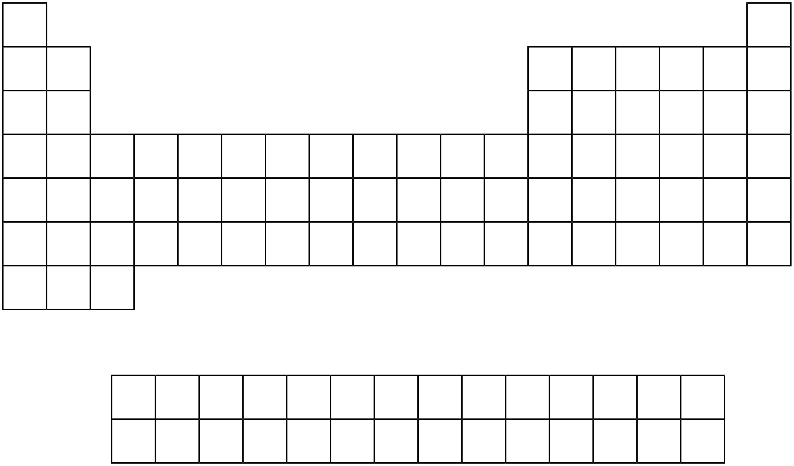

- The following diagram shows a visual representation of atomic radius sizes. The size of each circle is proportional to the size of each atom.
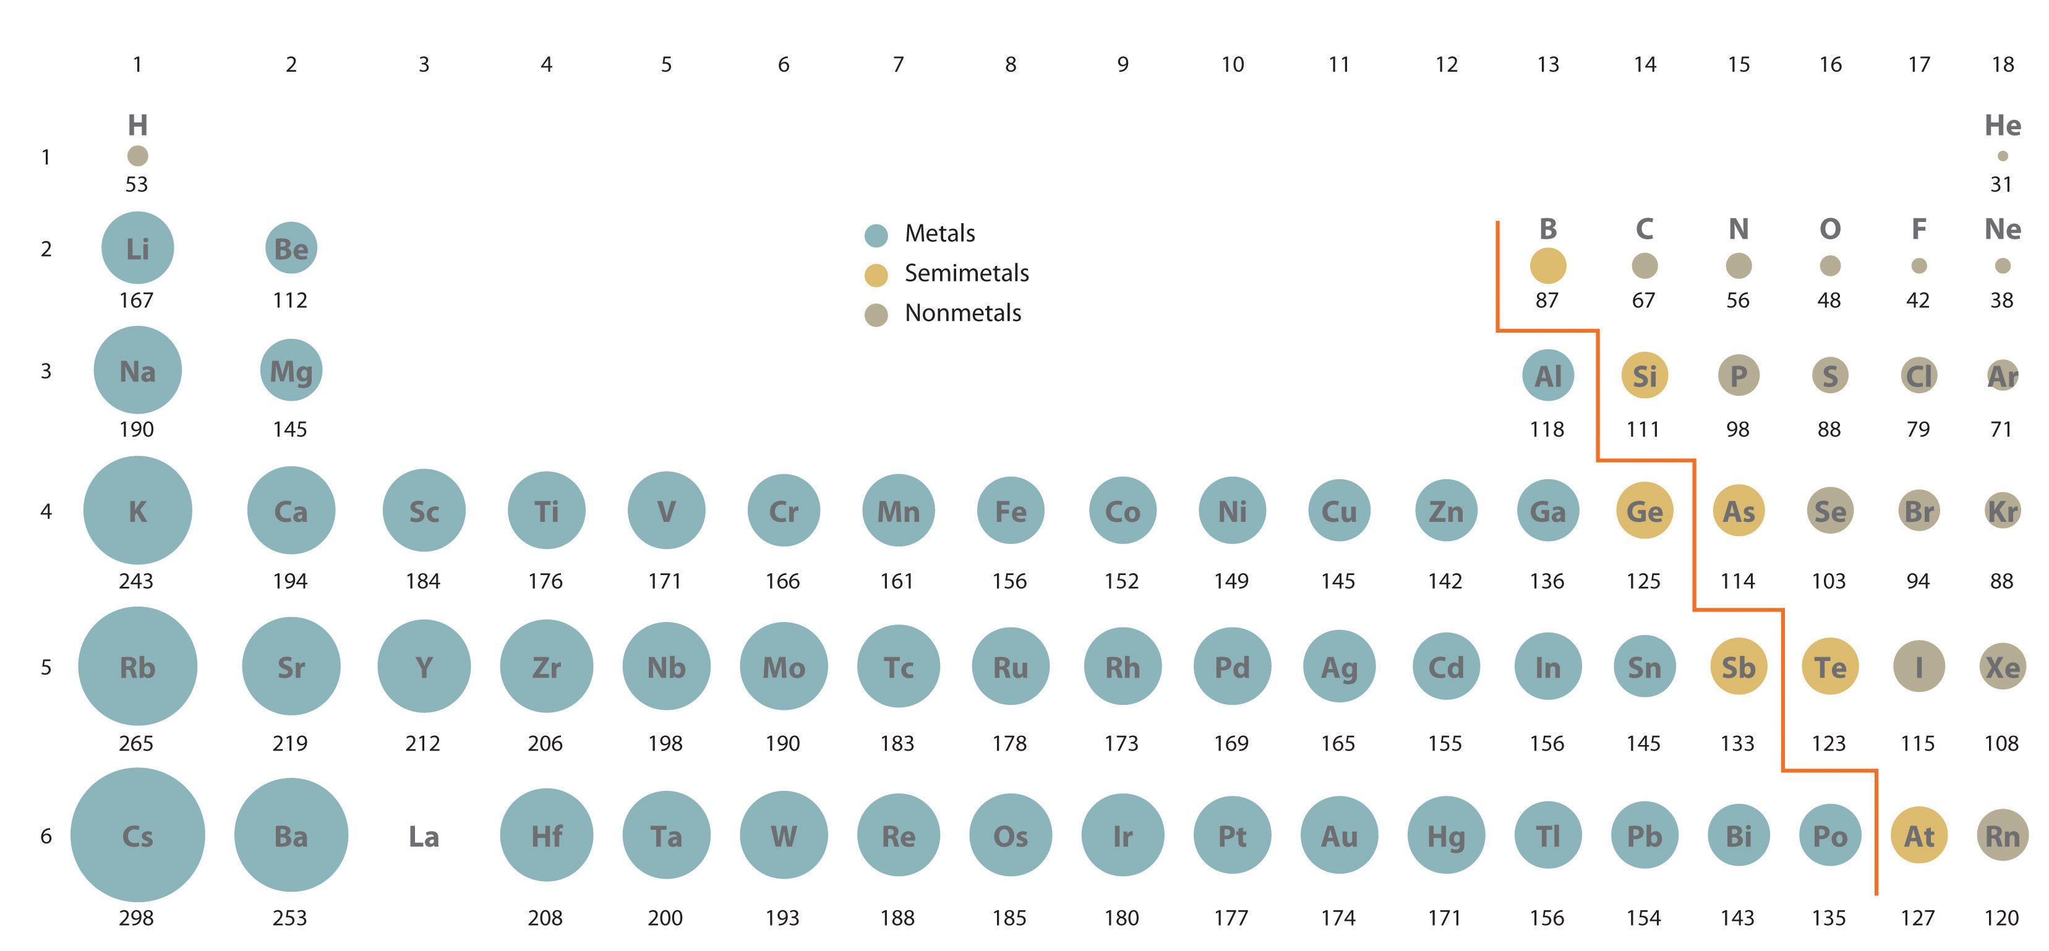

Explain the trend in atomic radius going across a period. (3 marks)

- (6 marks)

Diamond and graphite are two allotropes of carbon. Although both are made of carbon atoms, graphite is bonded in a 2D covalent structure whereas diamond is bonded in a 3D covalent structure.

- Circle the correct options in the table to compare the properties of graphite and diamond. (2 mark)

Property | Graphite | Diamond
Melting point | High / Low | High / Low
Electrical conductivity | High / None | High / None

Carbon nanotubes are an example of a nanomaterial. This allotrope of carbon forms cylinders with each carbon atom covalently bonded to three others. The diameter of nanotubes can be as small as 1 nm and can have lengths of up to several centimetres.

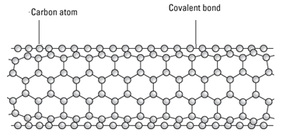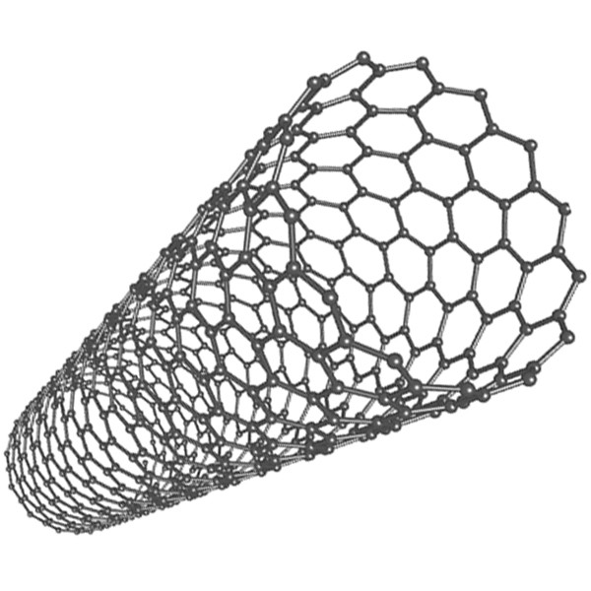

- Using your knowledge of the properties of graphite and diamond, predict the properties of carbon nanotubes. Justify your answer in terms of the structure and nature of bonding in the nanotube. (4 marks)

                - Electrical conductivity:

                - Strength:

- (8 marks)

- Draw labelled diagrams showing the difference in structure between silver (a metal) and silver chloride (an ionic substance). (2 marks)

Silver | Silver chloride

- Describe and explain the difference in malleability of silver and silver chloride. (3 marks)

- Describe and explain the difference in electrical conductivity of solid silver and solid silver chloride. (3 marks)

- (6 marks)

- Label the following diagram of water molecules to show the location of the covalent bonds and the intermolecular forces. (2 marks)

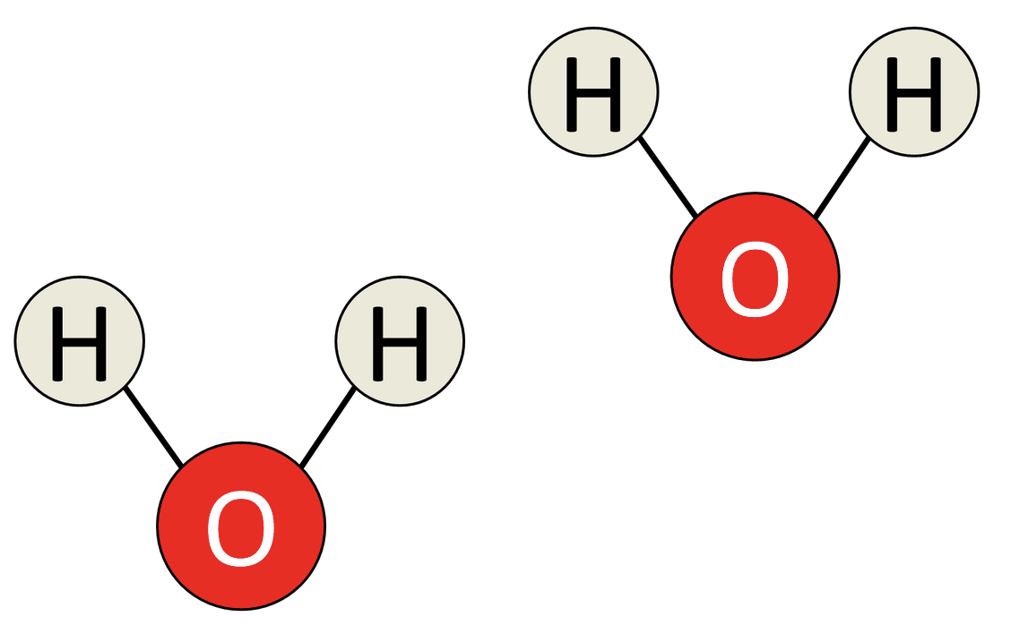

- All bonds are based on some form of electrostatic attraction. Describe the nature of electrostatic attraction involved in a covalent bond. (1 mark)

- Using the concept of covalent bonds and intermolecular forces, explain why the melting point of water is so different to the melting point of diamond. (3 marks)

- (2 marks)

The element gallium has the electron configuration 2, 8, 18, 3. Using the same notation, give the electron configuration of:

- A chlorine atom, Cℓ

- A calcium ion, Ca²⁺

- (3 marks)

Give IUPAC names for the following organic compounds:

Structure | Name
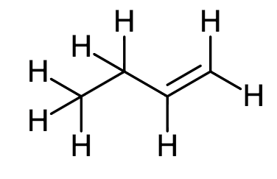
C
C
C
C

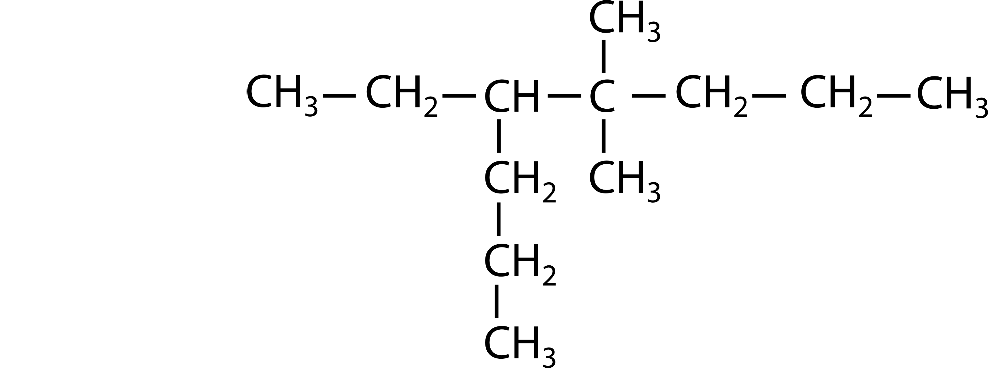

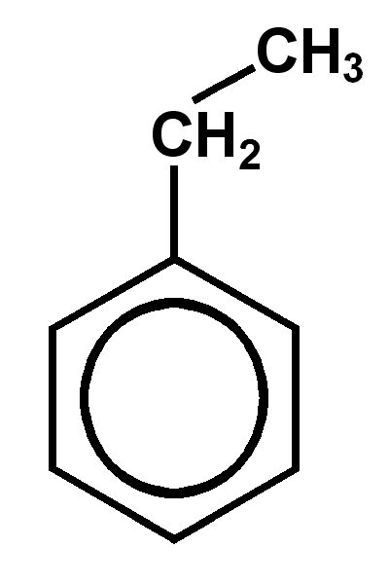
- (4 marks)

Draw structural diagrams of the two organic compounds named here:

2-iodo-3-methylpent-2-ene:

5,6-dimethyloct-2-ene:

- (3 marks)

For each of the following molecular equations, write an ionic equation which shows the reacting species in each equation. Do not include any spectator ions.

Molecular equation | 2 AgNO₃ (aq) + K₂CO₃ (aq) → 2 KNO₃ (aq) + Ag₂CO₃ (s)
Ionic equation

Molecular equation | 2 Mg(s) + O₂(g) → 2 MgO(s)
Ionic equation

Write balanced chemical equations for each of the following reactions. Show the structure and give the name of any organic products. (9 marks)

- Methane and chlorine gas react to completion

- Hydrogen gas is mixed with but-2-ene in the presence of a platinum catalyst

- A small amount of iodine is added to liquid benzene

- (3 marks)

Heptane and hept-1-ene are both colourless liquids which boil between 90 °C and 100 °C. They are soluble in each other and have very similar physical properties.

Describe a chemical test which would allow you to distinguish between a sample of heptane and a sample of hept-1-ene. Your answer should include a description of the test performed and what would be observed when this test is performed with each of the samples.

Chemical test:

Observation with heptane:

Observation with hept-1-ene:

PART 3 – EXTENDED ANSWER [80 marks – 40%]

This section contains five (5) questions. You must answer all questions. Write your answers in the spaces provided below.

Where questions require an explanation and/or description, marks are awarded for the relevant chemical content and also for coherence and clarity of expression. Lists or dot points are unlikely to gain full marks.

Final answers to calculations should be expressed to three significant figures.

Spare pages are included at the end of this booklet. They can be used for planning your responses and/or as additional space if required to continue an answer.
- Planning: If you use the spare pages for planning, indicate this clearly at the top of the page.
- Continuing an answer: If you need to use the space to continue an answer, indicate in the original answer space where the answer is continued, i.e. give the page number. Fill in the number of the question(s) that you are continuing to answer at the top of the page.

Suggested working time: 70 minutes.

- (10 marks)

Saponification (the making of soap) is the hydrolysis of plant oil or an animal fat by treating it with a strong base. Below is a chemical reaction depicting the conversion of a fat molecule (triglyceride) into glycerol and the salt of a fatty acid (soap).

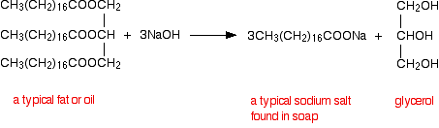

Triglyceride (fat) Salt of fatty acid (soap) + Glycerol

- Give the formula of the triglyceride in the form of C_{x}H_{y}O_{z}. (1 mark)

- Calculate the molar mass of a triglyceride molecule. (1 mark)

- If 0.140 moles of triglyceride reacts with an excess of sodium hydroxide, how many moles of the salt of a fatty acid are produced? (1 mark)

- What is the mass of salt of fatty acid resulting from the breakdown of 0.140 moles of triglyceride? (2 marks)

- Determine the percentage composition by mass of each element in a triglyceride molecule. (3 marks)

- Why is heat required for this reaction to occur? (1 mark)

- Is triglyceride an example of a hydrocarbon? Justify your answer. (1 mark)

- (21 marks)

Mercury is highly toxic and is a threat to human health, particularly to young children and pregnant women. Mercury occurs in a number of forms, including elemental (metallic) mercury, inorganic mercury (e.g. mercury chloride) and organic mercury (e.g. methylmercury). Aquatic organisms can acquire high concentrations of mercury through a process known as bioaccumulation.

Atomic absorption spectroscopy (AAS) is one method for analysing the concentration of mercury in soil and fish samples. A schematic figure of an atomic absorption spectrophotometer is shown below:

- In the above diagram, what are the purposes of the following parts? (3 marks)

                - Light source:

                - Flame:

                - Prism / Monochromator:

AAS calibration curves are constructed by measuring the absorbance of a set of reference standards with different concentrations. The absorbance data for a set of mercury standards is shown in the table below.

Concentration of mercury (ppm) | Absorbance
0 | 0.00
5 | 0.20
10 | 0.39
15 | 0.52
20 | 0.64
25 | 0.77

- Complete the graph below to show a calibration curve for mercury. (6 marks)

Note: So that you are able to answer part (c), ensure that the absorbance scale includes values up to 0.90 and that the concentration scale includes values up to 30 ppm.

If you make a mistake on this graph and need to restart, cross out this graph and use the one on page 36.

- An analysis of two samples containing mercury was then performed. Use your calibration curve to estimate the concentration of mercury in each sample. (1 mark)

Sample | Absorbance | Estimated concentration of mercury
1 | 0.44
2 | 0.90

- Compare the validity of the two estimations you made in part (c). (2 marks)

- Suggest two improvements to the method of this analysis which could improve the reliability of the results. (2 marks)

An alternate method of analysis elements in soil samples is mass spectrometry.

- Samples analysed by mass spectrometry must first be ionised. Briefly describe how this is achieved in a mass spectrometer. (2 marks)

- Name the part of the mass spectrometry which deflects the ions after they have been accelerated by an electric field. (1 mark)

Mass spectral analysis of an unknown sample yielded the following mass spectrum, with two elements (A and B) identified.

Element B
Element A

- Determine the relative atomic mass of Element B. You must show all working to obtain full marks. (2 marks)

- Identify the two elements present in the mass spectrum. (2 marks)

Element A:

Element B:

- (24 marks)

Many of the fuels we use of distilled from crude oil, using an apparatus similar to that shown below:

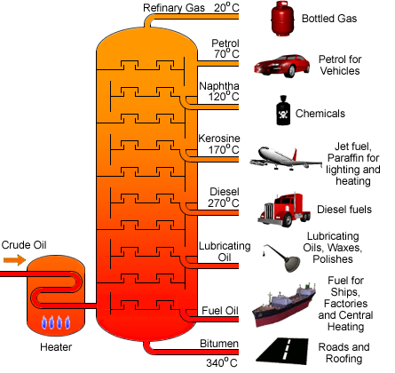

- Give a brief description demonstrating your understanding of what is occurring in the diagram. (2 marks)

- Name the physical property that this separation process is based on. (1 mark)

- A typical petro diesel molecule has the molecular formula C₁₆H₃₄. Biodiesel, however, is derived from renewable resources such as vegetable oil or animal fat and has a typical molecular formula C₁₇H₃₄O₂. Assuming complete combustion, write separate balanced equations for the combustion of (i) petro diesel and (ii) biodiesel. (2 marks)

One factor that needs to be considered when choosing a fuel source is the amount of carbon dioxide produced during the combustion of the fuel. For example, 1 tonne of petro diesel produces 3.11 tonnes of CO₂.

- In order to determine the mass of carbon dioxide released from the combustion of 1 tonne of biodiesel (C₁₇C₃₄O₂), first calculate the number of moles of biodiesel in 1 tonne (1000 kg). (3 marks)

- Determine the number of moles of carbon dioxide released from the combustion of one tonne of biodiesel. (1 mark)

- Determine the mass (in tonnes) of carbon dioxide produced from the combustion of 1 tonne of biodiesel. (2 marks)

- What mass of oxygen gas would be required for the combustion of 1 tonne of biodiesel? (3 marks)

- The heat of reaction is -10,700 kJ/mol for the combustion of petro diesel. Complete the graph below to show the enthalpy change during this reaction. Include appropriate labels on your graph. (5 marks)

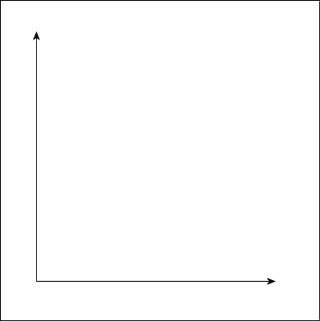

- Given that the heat of reaction for petro diesel is -10,700 kJ/mol, calculate the amount of heat released when 2,000 g of petro diesel (C₁₆H₃₄) undergoes combustion. (3 marks)

- List two factors other than CO₂ emissions and energy output that should be considered when comparing the advantages and disadvantages of diesel and biodiesel. (2 marks)

- (9 marks)

Esters are a group of organic substances containing carbon, hydrogen and oxygen. They are renowned for their pleasant odours. They are the chemicals often responsible for the smell and taste of bananas, oranges and pineapples.

- For each of the following hydrocarbons, list the molecular formula (in the form of C_{x}H_{y}O_{z}) and the simplified empirical formula. (4 marks)

Name and structural formula | Molecular formula | Empirical formula
pentyl ethanoate:
H₃C–C–O–CH₂–(CH₂)₃–CH₃
||
O

methyl salicylate:
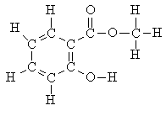

The ester ‘ethyl ethanoate’ is produced from the condensation reaction of ethanoic acid and ethanol. An additional molecule is produced as a by-product in this reaction.

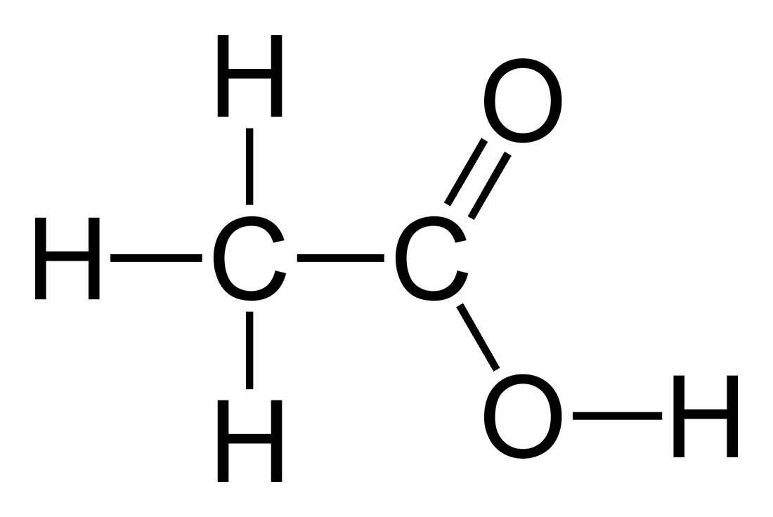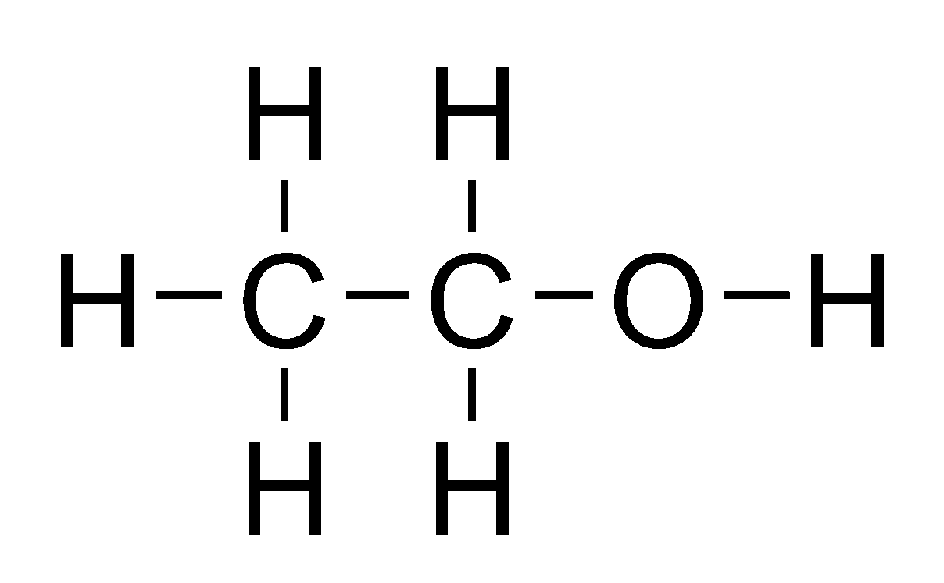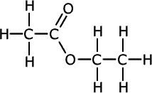
+ …………
⇌
+

Ethanoic acid Ethanol ⇌ Ethyl ethanoate ???

- Complete the above equation by writing the formula of the by-product. (1 mark)

- At the end of the reaction there will still remain a mixture of ethanoic acid, ethanol and ethyl ethanoate. The final step in the production of ethyl ethanoate is to separate it from the other reactants.

Substance | Solubility in water | Solubility in hexane | Boiling point
Ethyl ethanoate | Insoluble | Soluble | 77
Ethanol | Soluble | Insoluble | 78
Ethanoic acid | Soluble | Insoluble | 118

Use the information in the above table to propose a method for separating ethyl ethanoate from the other reactants.
- Name your separation method (1 mark)
- Draw a diagram of the separation apparatus (1 mark)
- Briefly explain how your method allows the substances to be separated (2 marks)

- (16 marks)

Instant cold packs have an inner compartment which contains solid ammonium nitrate (NH₄NO₃). Squeezing the chemical ice pack breaks the inner compartment, allowing the ammonium nitrate to mix with the surrounding water and dissolve.

NH₄NO₃(s) NH₄⁺(aq) + NO₃⁻(aq)

- Is the dissolution of ammonium nitrate exothermic or endothermic? (1 mark)

- Compare the enthalpy of the reactant (NH₄NO₃) to the enthalpy of the products. (1 mark)

Two chemistry students designed an investigation to determine which would be the best salt to use to make a chemical ice pack. The salts that they used in their reaction included potassium chloride, calcium chloride, sodium carbonate, sodium hydrogencarbonate and ammonium nitrate. It was hypothesised that the ammonium nitrate would result in the lowest temperature solution when dissolved in water.

- What was the independent variable? (1 mark)

- What was the dependent variable? (1 mark)

- List three variables that would need to be controlled. (3 marks)

- Draw a results table that would be suitable for collecting the information from this investigation. (4 marks)

- In their discussion, the students noted that the solution will continue to gain heat energy from the environment while the salt was still dissolving.
(i.) Is this a random error or a systematic error? Explain. (2 marks)

(ii.) The students’ results showed that the ammonium nitrate cooled down the solution by the greatest amount. Would the error described above invalidate the students’ results? Explain. (2 marks)

- Suggest an improvement which would increase the reliability of their results. (1 mark)

END OF EXAMINATION

Spare graph for Question 41b (Page 24)

SPARE WORKING SPACE
If you are continuing an answer on this page you MUST indicate this near the original question. If you do not indicate that your working is continued on this page then the work on this page will NOT be marked.

SPARE WORKING SPACE
If you are continuing an answer on this page you MUST indicate this near the original question. If you do not indicate that your working is continued on this page then the work on this page will NOT be marked.

SPARE WORKING SPACE
If you are continuing an answer on this page you MUST indicate this near the original question. If you do not indicate that your working is continued on this page then the work on this page will NOT be marked.

SPARE WORKING SPACE
If you are continuing an answer on this page you MUST indicate this near the original question. If you do not indicate that your working is continued on this page then the work on this page will NOT be marked.

SPARE WORKING SPACE
If you are continuing an answer on this page you MUST indicate this near the original question. If you do not indicate that your working is continued on this page then the work on this page will NOT be marked.

